Jose Sotelo
Page 11
Ms. Becerra
Biology Period 3
11/15/14

Peppered Moth Coloring as a Result of Pollution

- Introduction
  - Natural adaptation is a process in which well adapted/adapting organisms become more fit to survive and reproduce in their environment, which would pass on their strong traits to their children, and the weaker organisms die out and do not have (many) offspring.
  - In this lab, it was being tested if the reason behind darker colored Peppered moths, which would be dark grey as opposed to standard green-grey (almost white), becoming more dominant was a result of a dark colored environment that had been created by the Industrial Revolution.
  - A simulation was the experiment. A bird (played by a human) would eat moths (slips of paper).To properly simulate this, the independent variable, being the brightness of the background, would change from white to get a pre-industrialization score, to a dark background to get a post-industrialization score. The dependent variable was the amount of moths (played by colored slips of paper) that were caught by the “bird” in the allotted time.
  - The hypothesis tied to this experiment was that the darker colored moths would live longer in the dark environment because they would be harder to see. The “bird” will pick up the brighter colored moths instead.
- Materials
  - “Moths”- The key element of measurement for the experiment
    - Three different colors
      - An equal number of grey-green/white and dark grey
      - A small amount of Orange/Red for the rare mutated moths
  - 2 Backdrops- To switch after collecting the average for 5 trials for later data comparison
    - One White, One Grey
  - Forceps/Tweezers- to pick up the moths
  - A capable “bird”- a person who can properly hold the forceps and pick up the “moths”
  - An accurate stopwatch/timer- To give the “bird” only 15 seconds to “eat moths”
  - A small cup- To place the moths in, representing the bird stomach.
- Procedures
  - Two participants are required, one being the predator and the other keeping track of the time of the trial and recording data.
    - Steps
      - Step 1- Set the white backdrop on a flat surface. Place the “moths” on the surface and spread them evenly around. Make sure that there are no clusters on just one color.
      - Step 2- On the timekeeper’s word, the predator will pick up “moths” with the forceps. The predator may not pick up more than one “moth” at a time, for birds do not hunt in such a manner. They place each “moth” into the cup upon capture. Once 15 seconds have been reached, the timekeeper will tell the predator to stop.
      - Step 3- Record results for each individual moth color’s total casualties. Keep the deceased separate of the living.
      - Step 4- Repeat Step 2 and 3 until 5 total trials have elapsed.
      - Step 5- Switch the white backdrop to the grey
      - Step 6- Repeat Step 4
      - Step 7- Now graph the results, with one line being the white background/ pre-Industrial Revolution and the other being the dark backdrop/ post-Industrial Revolution.
White | Moth Populations
Generation | White | Orange | Grey
1 | 2 | 9 | 3
2 | 4 | 6 | 3
3 | 2 | 5 | 5
4 | 5 | 12 | 4
5 | 10 | 18 | 9
Average | 4.6 | 10 | 4.2
4 Results

Grey | Moth Populations
Generation | White | Orange | Grey
1 | 4 | 8 | 3
2 | 6 | 13 | 4
3 | 5 | 17 | 3
4 | 8 | 19 | 6
5 | 7 | 12 | 4
Average | 6 | 13.8 | 4.1

    - White Graph
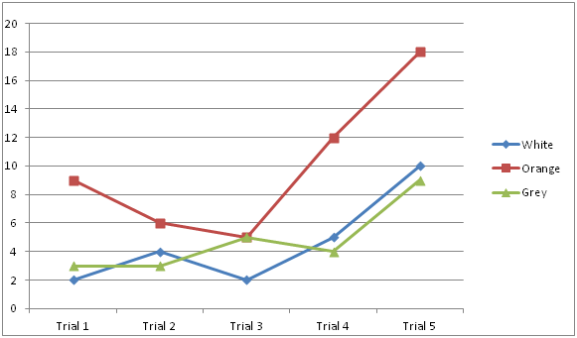

    - Black Graph
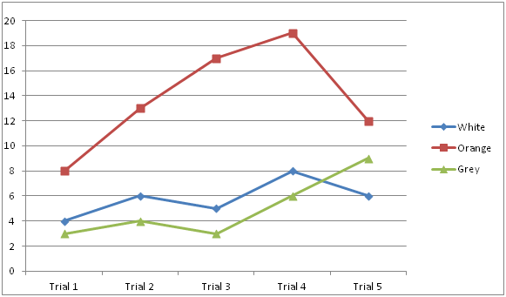

5 Discussion

As the evidence shows, the darker moths survived as a result of the darker environment. This is direct proof supporting the hypothesis. The hypothesis stated that if the environment darkened then the darker moths would have a higher survival rate. In this experiment, when the environment darkened, the dark moths had a significant increase in survival rate. This is the same as in the wild. When the environment darkened with pollution the dark moths flourished. Now, that pollution is clearing up and white moths are returning. This makes sense, for this experiment established the link between the coloring of an environment and the animals that can flourish. It is the ability to camouflage that decides whether an animal is lunch or the animal that gets to see the next day. However, this experiment is not entirely accurate for a multitude of reasons. It was a rough simulation. Since we were not actual birds hunting living moths in a broad, three dimensional environment that is the same as that in the home of the Peppered Moth, capture rates would have been drastically different for the birds are born hunters and moths are born to survive as prey. This changes the accuracy of the numbers but the end result would have been the same.
This ties into genetics and stealth. The survival of the fittest moths of the first generation will pass down their strengths onto their newborn. This idea of natural selection applies to all organisms, and humans too. The rich, fit and powerful are more likely to reproduce and have successful children than those who are poor, unfit/unhealthy and weak. These natural stealth tactics is something humans have adapted to suit their own needs as well. For example, army uniform varies for the environment that the soldier is in. For jungle/ forest environments, soldiers wear a type of green uniform that mimics the patterns of their surroundings. This is an infinitely useful tactic for survival.
To conclude, the Peppered Moth species darkened to adapt to the environment as a form of camouflage through natural selection.

